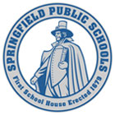
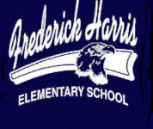
Learning at Home Welcome Letter

Dear Harris School Families,

We miss you and your children! First and foremost, we hope all families are doing well and trying to remain calm and positive during these uncertain times. We are thinking of all of you and are here to help in any way we can. Below are four different avenues of “Learning at Home” that might be helpful for you. None of them are mandatory and we encourage you to choose what option or combination of options would be the most beneficial and positive for your child, children, or family.

Students WILL NOT be graded or held responsible for these assignments. These options are provided in hopes that learning will continue in some capacity at home, not only for academic achievement purposes, but most importantly for a sense of normalcy and opportunities to stretch their brains and focus on what little minds should be focused on rather than the COVID-19 pandemic.

Please feel free to reach out to teachers or myself by email or dojo. Staff will not be in the building, but we will be checking our voicemails if you call us. We will be here no matter what and we will get through this together as a school community. Don’t hesitate to reach out if you need us.

Wishing Everyone Well,
Mrs. Harris
Principal
Frederick Harris Elementary School

ALL ACADEMIC RESOURCES PROVIDED BY THE SCHOOL WILL BE ON OUR HARRIS SCHOOL WEBSITE

https://harris.springfieldpublicschools.com/

Or Go to the SPS website: https://www.springfieldpublicschools.com/
Click on SCHOOLS
Scroll down and click on FREDERICK HARRIS

